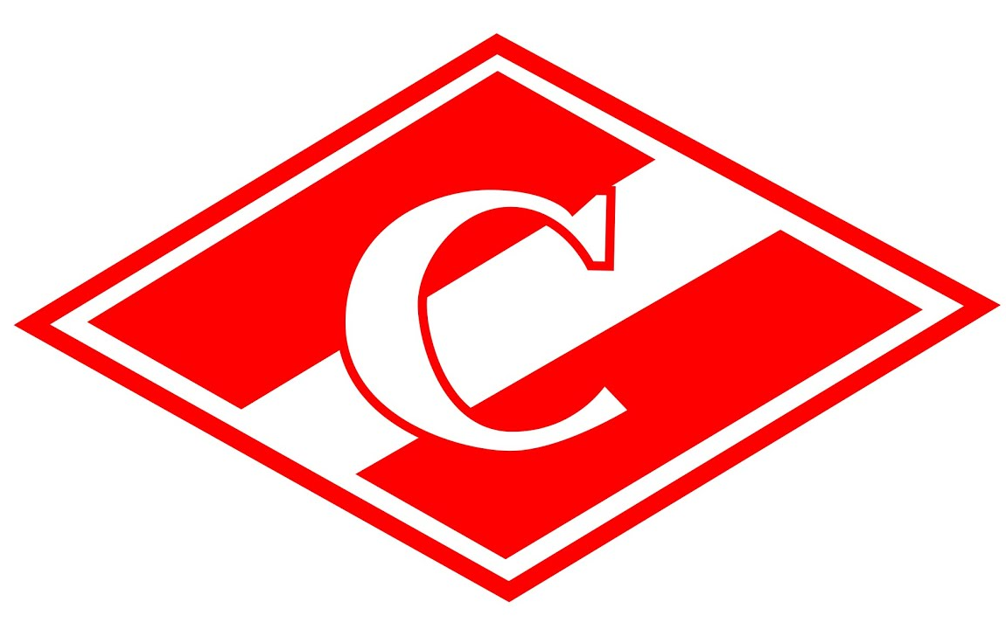
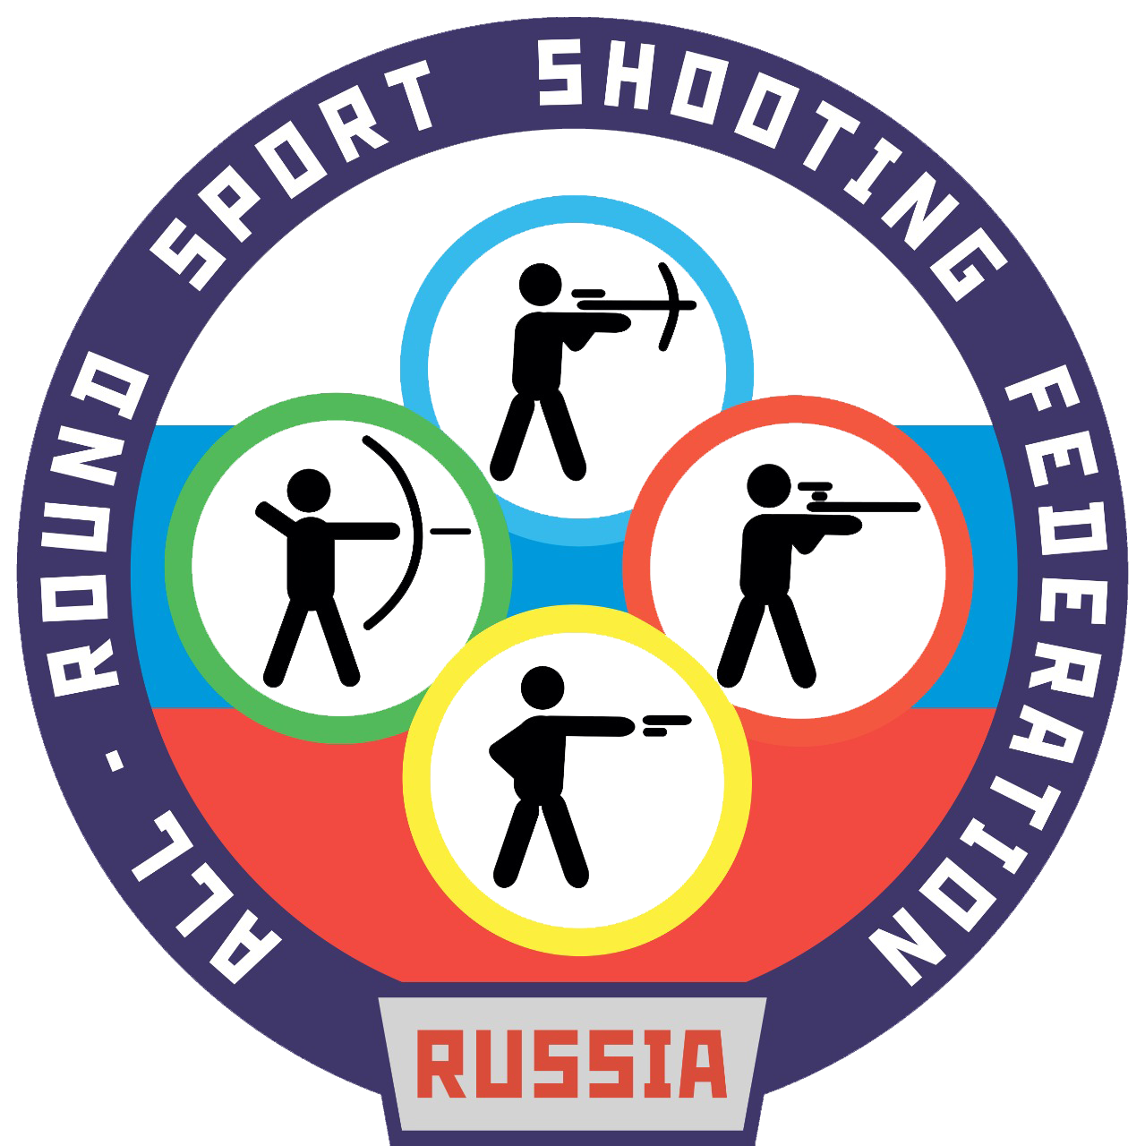

APPLICATION FORM
for participation in the the international football tournament for the prize of the 1972-best USSR player Evgeniy Lovchev «Caspian Region 2022» in commemoration of the 77th anniversary of the end of World War II
from the team _________________________

Country ___________________ The uniform colour _________________

№ | First name, Last name | Birth Date | Doctor’s admission
1 |  |  | admitted
2 |  |  | admitted
3 |  |  | admitted
4 |  |  | admitted
5 |  |  | admitted
6 |  |  | admitted
7 |  |  | admitted
8 |  |  | admitted
9 |  |  | admitted
10 |  |  | admitted

TEAM OFFICIALS

№ | Full Name (First, Last) | Birth Date | Sports Club (team, organization) | Signature
1
2

Team leader _______________________________________ _____________________ players are allowed to compete.
(Full Name) (Number of players)
.
Stamp
here
Signature____________________ Date ________________ Doctor _______________ __________________
(Signature) (Full name)

